Software Design Document
Smart Scholarship System



Submitted by
Nazik Kareem (S23BINFT1M01127)

Submitted to
Dr. Omer Riaz

Department of Information Technology
Faculty of Computing
The Islamia University of Bahawalpur

Summery
This Software Design Document (SDD) presents the design and architecture of the Smart Scholarship Management System. The system is a web-based platform developed to automate scholarship management processes, including student registration, scholarship applications, document verification, donor funding, and scholarship allocation. The system provides separate interfaces for Students, Donors, and Administrators, enabling efficient management of scholarship-related activities. The application follows the Model-View-Controller (MVC) architectural pattern and is developed using Django, MySQL, HTML, CSS, and JavaScript. The system ensures secure user authentication, efficient data management, and a user-friendly interface for all stakeholders. A key feature of the system is the integration of a Machine Learning module based on the K-Nearest Neighbors (KNN) algorithm. This module analyzes student academic performance, financial condition, location, and historical scholarship data to predict eligibility and recommend deserving students to donors. The recommendation mechanism improves transparency, fairness, and accuracy in scholarship distribution. This document describes the overall system architecture, database design, machine learning module, user interface design, controller functionalities, and data models. It also presents UML diagrams, Entity Relationship Diagrams (ERDs), and design specifications that guide the implementation and future enhancement of the Smart Scholarship Management System.

Table of Content

Table of Contents
Table of Content 3
1. Application Architecture 5
1.1 System Overview 5
1.2 Architectural Design 6
1.2.1 Client-Server Architecture 6
1.2.2 MVC Architecture 6
1.3 System Architecture Diagram 8
1.4 Technology Stack 9
1.4.1 Frontend Technologies 9
1.4.2 Backend Technologies 9
1.4.3 Database Technologies 10
1.4.4 Machine Learning Technologies 10
1.5 MVC Components 10
1.5.1 Models 10
1.5.2 Views 11
1.5.3 Controllers 11
1.6 Controller Design 11
1.6.1 Authentication Controller 12
1.6.2 Student Controller 12
1.6.3 Donor Controller 12
1.6.4 Admin Controller 13
1.6.5 Recommendation Controller 13
1.7 External Libraries and Tools 13
1.8 Machine Learning Module Design 14
1.8.1 KNN Algorithm 14
1.8.2 Training Process 14
1.8.3 Prediction Process 15
1.9 UML Diagrams 16
1.9.1 Use Case Diagram 16
1.9.2 Class Diagram 18
1.9.3 Sequence Diagrams 18
1.10 Coding Standards and Conventions 20
2. Data Model Schema 21
2.1 Schema Overview & Relationships 21
2.2 Condensed Data Dictionary 22
3. User Interface 27
3.1 Design Philosophy 27
3.2 User Interface Overview 27
3.3 Major User Interface Screens 27
3.3.1 Login and Registration Screen 27
3.3.2 Student Dashboard Screen 27
3.3.3 Scholarship Application Form 28
3.3.4 Donor Dashboard Screen 28
3.3.5 Recommendation Screen 28
3.3.6 Admin Dashboard Screen 29
3.4 Input Validation Matrix 29
3.5 Feedback Alerts & Notification Subsystem 30

- Application Architecture

1.1 System Overview

The Smart Scholarship Management System is a web-based platform developed to automate and streamline the scholarship management process. The system allows students to register, apply for scholarships, upload required documents, and track their application status. Donors can create scholarship funds and search for deserving students, while administrators manage scholarships, verify applications, and oversee system operations.

The system also incorporates a Machine Learning module based on the K-Nearest Neighbors (KNN) algorithm to identify and recommend deserving students based on academic performance, financial condition, location, and historical scholarship data. This intelligent recommendation mechanism improves transparency, fairness, and efficiency in scholarship allocation.

1.2 Architectural Design

The Smart Scholarship Management System follows a Client-Server Architecture combined with the Model-View-Controller (MVC) design pattern.

1.2.1 Client-Server Architecture
In this architecture, users interact with the system through a web browser (client), while all processing and data management are handled by the server. The client sends requests to the server, and the server processes these requests, retrieves required data from the database, and returns the appropriate response.

**Benefits:**

* Centralized data management
* Improved security
* Easy maintenance
* Scalability

1.2.2 MVC Architecture

The MVC architecture separates the application into three major components:
Model

- Handles database operations.
- Stores application data.
- Manages business entities.

**View**

- Provides user interfaces.
- Displays information to users.
- Collects user input.

**Controller**

- Processes user requests.
- Implements business logic.
- Communicates between Models and Views.

### MVC Architecture Diagram

```text
+-------------+
| View |
| (Frontend) |
+-------------+
|
v
+-------------+
| Controller |
| Business |
| Logic |
+-------------+
|
v
+-------------+
| Model |
| Database |
+-------------+
```

---

1.3 System Architecture Diagram

The overall architecture of the Smart Scholarship Management System is illustrated below:

```text
+------------+
| Students |
+------------+
|
+------------+
| Donors |
+------------+
|
+------------+
| Admins |
+------------+
|
v
+----------------+
| Web Browser |
+----------------+
|
v
+----------------+
| Django Backend |
+----------------+
/ \
/ \
v v
+------+ +--------+
|MySQL | | KNN |
| DB | | Model |
+------+ +--------
The backend communicates with the database for storing and retrieving information and with the Machine Learning module for student recommendations.

1.4 Technology Stack

The system uses modern web technologies to ensure performance, security, and scalability.

1.4.1 Frontend Technologies
The frontend is developed using:

* HTML5
* CSS3
* JavaScript
* Bootstrap

These technologies provide responsive and user-friendly interfaces for students, donors, and administrators.

1.4.2 Backend Technologies

The backend is developed using:

* Django Framework (Python)
Django handles user authentication, business logic, routing, and communication with the database and machine learning module.

1.4.3 Database Technologies

The system uses:
* MSQL Database
MySQL stores user records, scholarship information, applications, funding details, and recommendation results.

1.4.4 Machine Learning Technologies

The recommendation system is developed using:

* Python
* Scikit-Lear
The K-Nearest Neighbors (KNN) algorithm is implemented using Scikit-Learn to predict scholarship eligibility
---

1.5 MVC Components

1.5.1 Models

Models represent database entities and handle data operations.

The proposed models are:

* User
* Student
* Donor
* Scholarship
* Application
* Document
* Funding
* Recommendation
These models store and manage all information required by the system.

1.5.2 Views

Views represent the user interface
The proposed views include
* Login Page
* Registration Page
* Student Dashboard
* Donor Dashboard
* Admin Dashboard
* Scholarship Application Form
* Recommendation Page
* Verification Page
Views are responsible for displaying information and receiving user input.

1.5.3 Controllers

Controllers process user requests and execute business logic
The proposed controllers are:

* Authentication Controller
* Student Controller
* Donor Controller
* Admin Controller
* Recommendation Controller

Controllers communicate with models and views to perform system operations.

1.6 Controller Design

1.6.1 Authentication Controller

The Authentication Controller manages user registration, login, logout, and password recovery.

**Functions:**

| Function | Description |
| ---------------- | ------------------- |
| registerUser() | Register a new user |
| loginUser() | Authenticate user |
| logoutUser() | End user session |
| forgotPassword() | Reset password

1.6.2 Student Controller
The Student Controller handles student-related operations.
**Functions:**
| Function | Description |
| ------------------ | ------------------------------ |
| applyScholarship() | Submit scholarship application |
| uploadDocuments() | Upload required documents |
| viewStatus() | Track application status |

1.6.3 Donor Controller
The Donor Controller manages donor activities.
**Functions:**
| Function | Description |
| ------------------- | ----------------------------- |
| registerDonor() | Register donor account |
| createFunding() | Create scholarship funding |
| findStudents() | Search students |
| assignScholarship() | Assign scholarship to student |

1.6.4 Admin Controller
The Admin Controller manages administrative tasks.
**Functions:**
| Function | Description |
| -------------------- | -------------------- |
| verifyApplications() | Verify applications |
| approveApplication() | Approve applications |
| rejectApplication() | Reject applications |
| manageScholarships() | Manage scholarships |
| trainModel() | Train KNN model |

1.6.5 Recommendation Controller

The Recommendation Controller manages machine learning recommendations.

**Functions:**

| Function | Description |
| -------------------- | ------------------------- |
| predictEligibility() | Predict eligible students |
| getRecommendations() | Generate recommendations |

1.7 External Libraries and Tools

The system utilizes several external libraries and development tools.
Django Framework
Django is used to develop the backend of the application and manage server-side operations.
Scikit-Learn
Scikit-Learn provides machine learning functionality and supports implementation of the KNN algorithm.
MySQL Connector
MySQL Connector enables communication between Django and the MySQL database.
GitHub
GitHub is used for version control, source code management, and team collaboration.

1.8 Machine Learning Module Design

The Smart Scholarship Management System integrates a Machine Learning module to recommend deserving students.

1.8.1 KNN Algorithm

The K-Nearest Neighbors (KNN) algorithm is a supervised machine learning algorithm used for classification
The algorithm compares a new student's information with historical scholarship records and identifies similar students based on selected features.

Features Used
* Academic Performance
* Financial Condition
* Location
* Previous Approval History

1.8.2 Training Process
The KNN model is trained using historical scholarship data.
**Steps:**
1. Collect historical student records.
2. Clean and preprocess data.
3. Convert categorical values into numerical values.
4. Split dataset into training and testing sets.
5. Train KNN model.
6. Save trained model

1.8.3 Prediction Process

The trained model predicts eligibility for new applicants.
**Steps:**
1. Receive student application data.
2. Extract feature values.
3. Calculate similarity with historical records.
4. Identify nearest neighbors.
5. Predict eligibility.
6. Generate recommendation score.

### Recommendation Workflow Diagram

```text
Student Data
|
v
Feature Extraction
|
v
KNN Model
|
v
Eligibility Prediction
|
v
Recommended Students
```

1.9 UML Diagrams

The following UML diagrams are used to represent the design of the system:

1.9.1 Use Case Diagram

Shows interactions between Students, Donors, Admins, and the system.
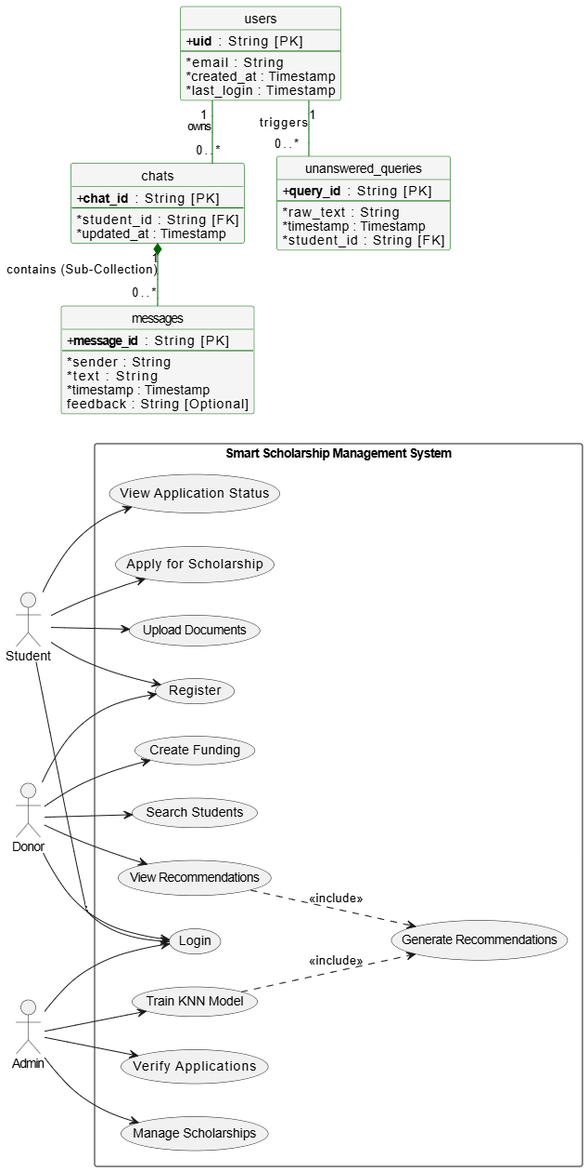

1.9.2 Class Diagram
Represents system classes, attributes, methods, and relationships.
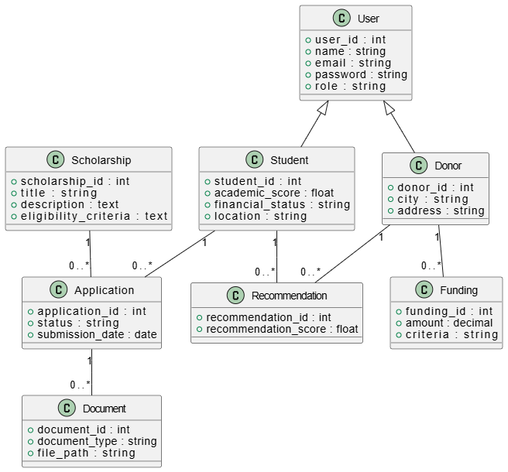

1.9.3 Sequence Diagrams
Sequence diagrams illustrate the flow of messages between system components during:
* User Authentication
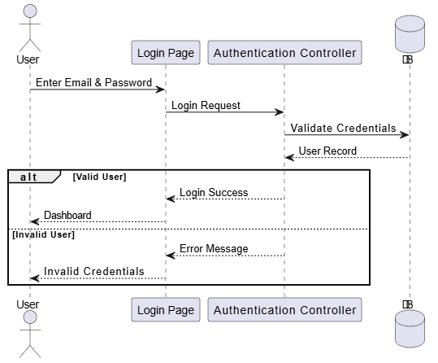
* Scholarship Application
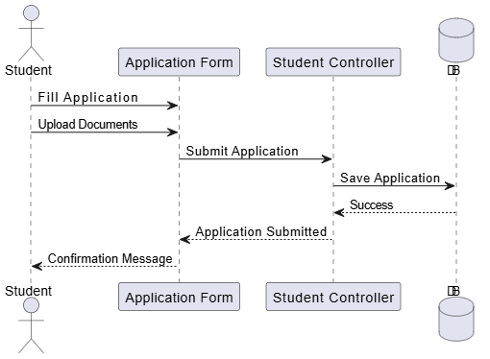
* Donor-Student Matching
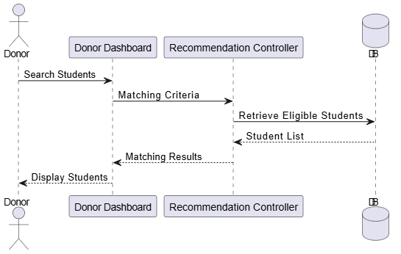
* Smart Recommendation
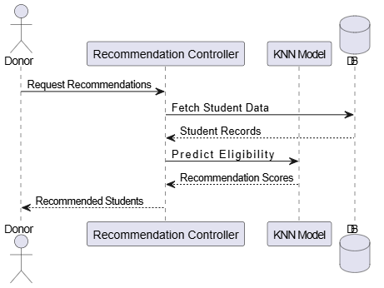

1.10 Coding Standards and Conventions
To ensure maintainability and readability, the following coding standards will be followed:
* MVC architectural pattern.
* Meaningful class and variable names.
* Proper indentation and formatting.
* Reusable and modular code.
* Input validation on all forms.
* Exception handling for errors.
* Secure password storage using hashing.
* Code documentation and comments.
* GitHub-based version control

- Data Model Schema
The Smart Scholarship Management System relies on a normalized relational database (RDBMS) designed to ensure data consistency, minimize redundancy, and support high-speed algorithmic candidate recommendations.

2.1 Schema Overview & Relationships
The relational architecture mappings and cardinality rules between core operational system tables are defined in the matrix below:
Entity Relationship | Cardinality | Functional Context
User → Student | One-to-One | Links system credentials to applicant metadata.
User → Donor | One-to-One | Links system credentials to donor profiles.
Student → Application | One-to-Many | Allows students to apply for multiple scholarships.
Scholarship → Application | One-to-Many | Tracks all applications submitted to a specific grant.
Application → Document | One-to-Many | Attaches verification files to a specific application.
Donor → Funding | One-to-Many | Manages multiple fund allocations under a single donor account.
Donor → Recommendation | One-to-Many | Stores KNN-generated matching recommendations for sponsors.
Student → Recommendation | One-to-Many | Indexes students across multiple matching recommendation pools.

ER Diagram
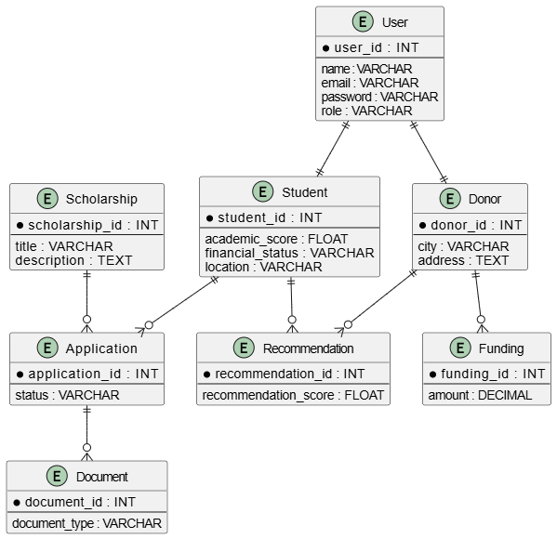

2.2 Condensed Data Dictionary
The tables below provide precise schema constraints and field configurations for the primary database entities:
Table: User
Field Name | Type (Size) | Key | Description
user_id | INT(11) | PK | Unique system user identifier.
name | VARCHAR(100) | - | Full name of the individual or entity.
email | VARCHAR(100) | Unique | Registered email address (login credential).
password | VARCHAR(255) | - | Securely hashed user password.
role | ENUM | - | Role flags: 'Student', 'Donor', 'Admin'.
Table: Student
Field Name | Type (Size) | Key | Description
student_id | INT(11) | PK | Unique applicant identifier.
user_id | INT(11) | FK | References User(user_id).
academic_score | FLOAT | - | Normalized academic performance metric (CGPA/%).
financial_status | VARCHAR(50) | - | Economic grouping status identifier.
location | VARCHAR(100) | - | Geographical city/region tracking string.

Table: Donor
Field Name | Type (Size) | Key | Description
donor_id | INT(11) | PK | Unique scholarship provider key.
user_id | INT(11) | FK | References User(user_id).
city | VARCHAR(100) | - | Donor city location.
address | TEXT | - | Complete physical or official address details.

Table: Scholarship
Field Name | Type (Size) | Key | Description
scholarship_id | INT(11) | PK | Unique programmatic listing identifier.
title | VARCHAR(150) | - | Public descriptive title of the grant.
description | TEXT | - | Full programmatic parameters and scope details.
eligibility_criteria | TEXT | - | Rule configurations defining candidate restrictions.

Table: Application
Field Name | Type (Size) | Key | Description
application_id | INT(11) | PK | Unique submission entry tracking record.
student_id | INT(11) | FK | References Student(student_id).
scholarship_id | INT(11) | FK | References Scholarship(scholarship_id).
status | VARCHAR(20) | - | Lifecycle status: 'Pending', 'Approved', 'Rejected'.
submission_date | DATE | - | Timestamp noting formal package upload point.

Table: Document
Field Name | Type (Size) | Key | Description
document_id | INT(11) | PK | Unique compliance digital asset placeholder.
application_id | INT(11) | FK | References Application(application_id).
document_type | VARCHAR(50) | - | Types: 'CNIC', 'Transcript', 'Income', 'Domicile'.
file_path | VARCHAR(255) | - | Absolute path tracking file location pointer.

Table: Funding
Field Name | Type (Size) | Key | Description
funding_id | INT(11) | PK | Unique financial allocation entry tracking record.
donor_id | INT(11) | FK | References Donor(donor_id).
amount | DECIMAL(10,2) | - | Total capital allocation registry pool balance.
criteria | TEXT | - | Target matching rules specifying profile filters.
students_supported | INT | - | Maximum concurrent slot allocation allowance budget.

Table: Recommendation
Field Name | Type (Size) | Key | Description
recommendation_id | INT(11) | PK | Unique algorithmic matching entry log.
donor_id | INT(11) | FK | References Donor(donor_id).
student_id | INT(11) | FK | References Student(student_id).
recommendation_score | FLOAT | - | KNN structural distance matching metric (0.0 to 1.0).

- User Interface

3.1 Design Philosophy
The Smart Scholarship Management System provides a simple, responsive, and user-friendly interface optimized across devices for Students, Donors, and System Administrators. The front-end framework highlights seamless navigation, high readability, and effortless form submissions.
Core Design Principles
- Simplicity: Clutter-free layouts focusing on user goals.
- Consistency: Standardized navigation schemas and design components across dashboards.
- Responsiveness: Fully adaptive frameworks rendering properly on mobile, tablet, and desktop viewports.
- Accessibility: High contrast ratios, semantic components, and screen-reader friendliness.
- Security: Explicit view routing, input clearing, and visual protection constraints.

3.2 User Interface Overview
The portal architecture breaks down into three separate dedicated, role-specific control boundaries:
- Student Interface: Optimized for simplified scholarship application tracking, discovery, and profile uploads.
- Donor Interface: Tailored to control balance provisions and read real-time applicant data matches.
- Admin Interface: Engineered for compliance handling, ledger audits, and automated background machine learning engine initialization.

3.3 Major User Interface Screens

3.3.1 Login and Registration Screen
Purpose: Secures authorization entry points and handles profile creation workflows safely.
Key Features: Self-service registration forms, explicit credential authentication checking, and reset pathways.
■ Secure Access Wireframe Mock ■
[ Email Input field ]
[ Password Input field ]
[ Action Button: Log In ]
[ Text Link: Create an Account / Register ]
[ Text Link: Forgot Password? ]

3.3.2 Student Dashboard Screen
Purpose: Central activity hub providing students direct access to programmatic tools.
Key Features: Real-time application cycle tracking, document upload indicators, and secure management profiles.
■ Student Central Panel Wireframe Mock ■
+ Apply for a New Scholarship
↑ Upload Verifiable Documentation Assets
⌛ View Active Request Pipeline State
↪ Profile Configuration & Secure Sign-Out

3.3.3 Scholarship Application Form
Purpose: Multi-step intake flow collecting applicant profile criteria inputs.
Key Features: Progress steps isolating personal data, academic logs, household income facts, and verification arrays.
■ Application Processing Form Wireframe Mock ■
Step 1: Core Personal & Contact Fields
Step 2: Academic Metrics Data (CGPA/Percentage)
Step 3: Financial Background Facts
[ Button: Submit Secure Application Package ]

3.3.4 Donor Dashboard Screen
Purpose: Management pane enabling grant creators to deploy support pools and audit candidates.
Key Features: Fund provisioning interfaces, ad-hoc applicant database search, and recommendations tables.
■ Sponsor Control Dashboard Wireframe Mock ■
⊕ Deploy New Financial Allocation / Funding Bucket
🔍 Smart Filter & Search Student Matrix Profiles
★ View ML-Generated Deserving Candidates Panel

3.3.5 Recommendation Screen
Purpose: Visually displays optimal student matches derived through spatial computation layers.
Key Features: Detailed demographic score sheets, target academic indices, and explicit matching confidence weights.
■ KNN Recommendations Panel Wireframe Mock ■
------------------------------------------
| Student Profile | Fit Score | Action |
------------------------------------------
| John Doe | 94.2% | [View] |
| Jane Smith | 89.7% | [View] |
------------------------------------------

3.3.6 Admin Dashboard Screen
Purpose: Central administrative back-office system command terminal.
Key Features: Manual document status resolution tools, master scholarship registry controls, and ML model training buttons.
■ Global Admin Panel Wireframe Mock ■
⚙ Document Quality & Application Verification Ledger
⚙ Manage Registry Listings & Grant Directories
⚙ Trigger Background KNN Spatial Model Training

3.4 Input Validation Matrix
To protect structural database transactional consistency, front-end data elements undergo synchronous input format assertion testing before API routing actions execute:
Target Input Field | Strict Structural Validation Rule | System Protection Context
User Email Field | Valid standard web structure string schema verification. | Blocks malformed text strings before reaching API authorization lines.
Password Entry | Minimum threshold rule of 8 characters. | Enforces stronger baseline entropy characteristics.
Academic Score | Enforces accurate bounding limitations matching local scales. | Restricts score entry variables beyond strict parameters.
Funding Amount | Must present a positive numerical metric higher than zero. | Eliminates empty allocations or unexpected inversion accounting logs.
Documentation Uploads | Strict white-listed format enforcement: PDF, JPG, or PNG formats. | Defends framework layers from malicious script execution threats.

3.5 Feedback Alerts & Notification Subsystem
The system alerts users of changes in operational state using standardized notifications classified into three functional alert levels:
System Context Messaging Buckets
- Green Alert Level (Success Messages): 'Registration Complete', 'Application Successfully Submitted', and 'Documentation Assets Uploaded'.
- Red Alert Level (Error Handlers): 'Invalid Identification Metrics Provided', 'Required Text Block Missing', and 'Unsupported Asset File Extension'.
- Blue Alert Level (Lifecycle State Updates): 'Application Document Status Set to Approved', 'Application Denied by Auditor', and 'New Spatial Profile Recommendation Match Vector Generated'.

